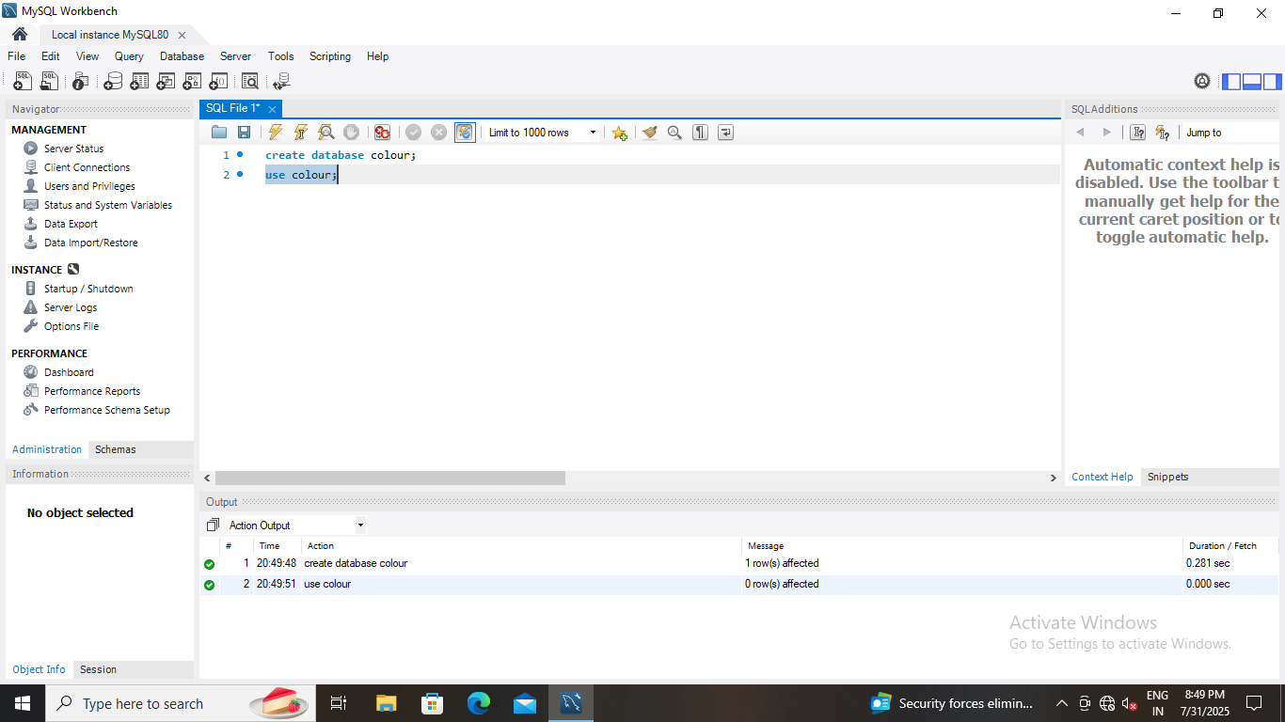

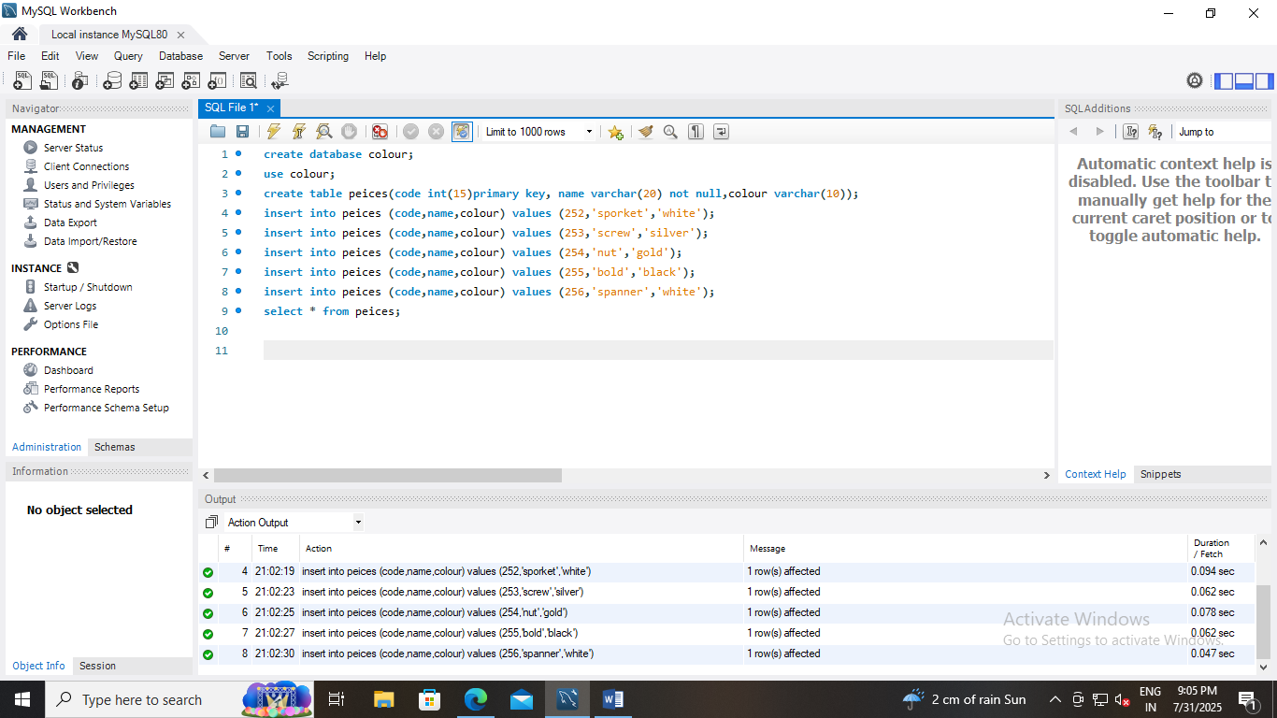

create database colour;
use colour;
create table pieces (code int(15)primary key, name varchar(20) not null, colour varchar(10));
insert into peices (code,name,colour) values (252,'sporket','white');
insert into peices (code,name,colour) values (253,'screw','silver');
insert into peices (code,name,colour) values (254,'nut','gold');
insert into peices (code,name,colour) values (255,'bold','black');
insert into peices (code,name,colour) values (256,'spanner','white');
select * from peices;
